**CREDIT CARD**

**WEEKLY**

**STATUS REPORT**



**Project Object**

**To develop a comprehensive credit card**

**weekly dashboard that provides real-time**

**insights into key performance metrics and**

**trends, enabling**

**stakeholders to monitor**

**and analyze credit card**

**operations effectively .**

**DAX Queries**

1. **Age Group :**

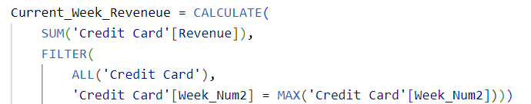

1. **IncomeGroup :**

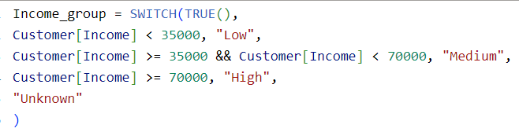

1. **Week_Num 2 :**



1. **Revenue :**



**5.Current week Revenue :**

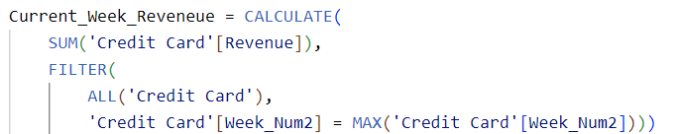

1. **Previous Week Revenue :**

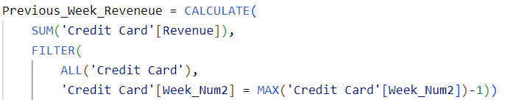

1. **WOW Revenue :**



1. **Previous Week Transaction Amount:**

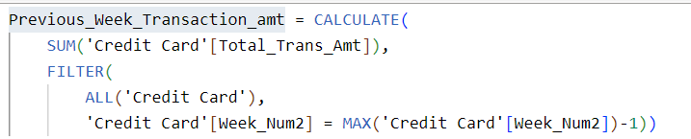

1. **Current Week Transaction Amount:**

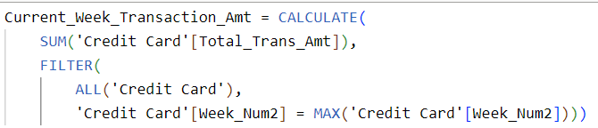

1. **WOW Transaction Amount :**



1. **Current Week Customer Count:**



1. **Previous week Customer Count:**

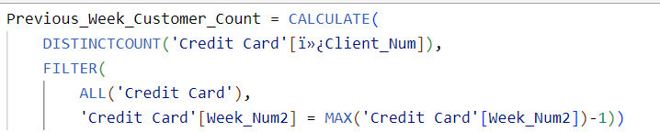

1. **WOW Customer Count Increase Percentage:**



**Project Insights-**

**Week 53 (31st Dec) WoW change:**

**• Revenue increased by 28.8%,**

**• Total Transaction Amt increased by 35.0%**

**• Customer count increased by 0.21%**

**Overview YTD:**

**• Overall revenue is 57M**

**• Total interest is 8M**

**• Total transaction amount is 46M**

**• Male customers are contributing more in revenue 31M, female 26M**

**• Blue & Silver credit card are contributing to 93% of overall transactions**

**• TX, NY & CA is contributing to 68%**

**• Overall Activation rate is 57.5%**

**• Overall Delinquent rate is 6.06%**